**NJIT | CS 631 | DATA MANAGEMENT SYSTEMS DESIGN**

**Project Group 12**

**Komaldeep Kaur Bhatia | Saumya Choksi | Akilesh Kannamukkala**

**Deliverable 1 -- Phase 1 Report**

1. **Outline of this phase:**

* Analyze Project description and identify Entities, Attributes and Relationship types for Entity-Relationship Diagram.
* E-R Diagram is being used to design and analyze relational databases used in WALLET.
* Identify Primary keys for all Entities and structural constraints along with assumptions for making E-R Diagram.

1. **Building an ER Diagram:**

* Refer to pages 2 and 3.

1. **Assumptions:**

* A User_id is generated by WALLET when a new user creates a WALLET account.
* The user’s bank account is linked to the same mobile number or the email specified in the WALLET app during account creation.
* Not all WALLET users have linked their bank accounts.
* User has to choose a username and password during account creation.
* A Bank_account_id is generated by WALLET based on a unique combination of Bank_id and account_number when a user links and verifies his bank account.
* The first bank account linked by a user is considered to be the User’s Primary account.
* Transaction status can either be Completed, In Progress or Cancelled.

1. **List of Additional Keys for Entity types:**

* User Master: User_ID (Generated by WALLET for every user)
* Login_details: Username (Provided by the user during registration)
* Bank Details: Bank_ID (Generated by WALLET for every bank account linked)
* Transactions: Transaction_ID (Generated by WALLET for every send or request transaction initiated by the user)
* Transactions: Request_ID (Generated by WALLET for a request transaction)

1. **Challenges Faced:**

* Structural constraints can vary based on the assumptions.
* Storing multiple emails for a single WALLET user
* Linking multiple account owners to 1 bank account in case of Joint account type

**ER Schema Diagram for The Wallet Payment Network**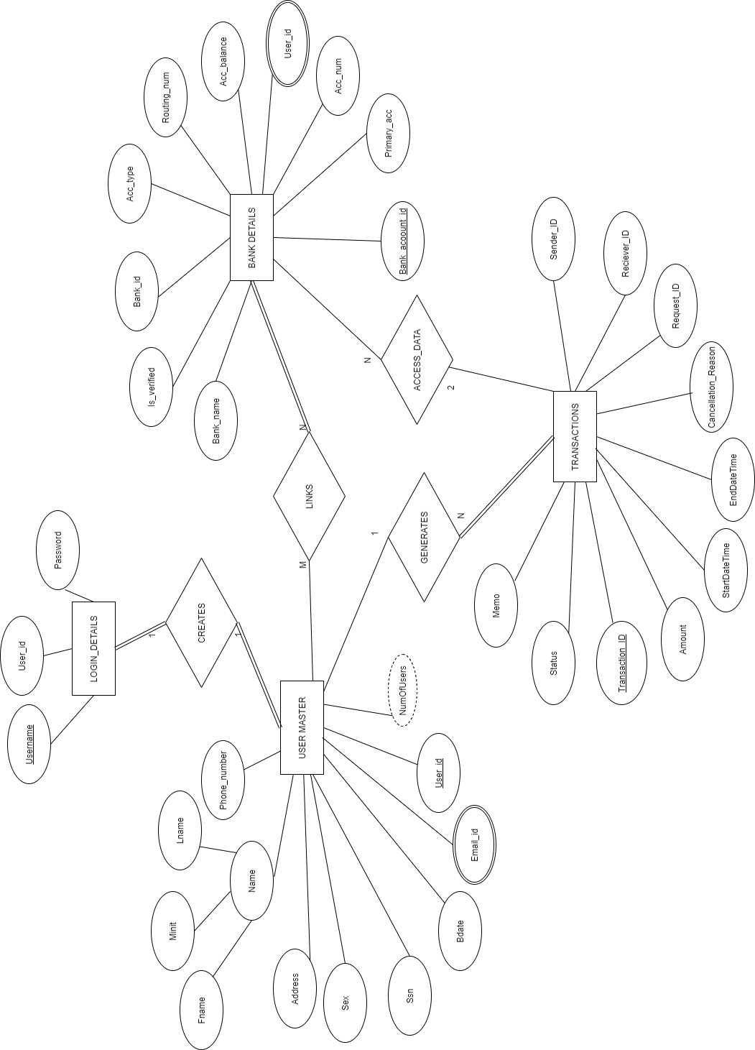

**ER Schema Diagram for The Wallet Payment Network**

**with (min, max) constraints**

